Grove - Barometer Sensor

Introduction
This Grove - Barometer Sensor features a Bosch BMP085 high-accuracy chip to detect barometric pressure and temperature. It can widely measure pressure ranging from 300hPa to 1100hPa, AKA +9000m to -500m above sea level, with a super high accuracy of 0.03hPa(0.25m) in ultra-high resolution mode.The chip only accepts 1.8V to 3.6V input voltage. However, with outer circuit added, this module becomes compatible with 3.3V and 5V. Therefore, it can be used on Arduino/Seeeduino or Seeeduino Stalker without modification.It is designed to be connected directly to a micro-controller via the I2C bus.
Model:SEN05291P
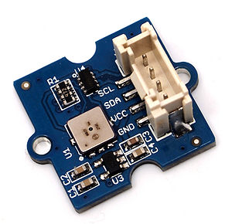
Features
- Digital two wire (I2C) interface
- Wide barometric pressure range
- Flexible supply voltage range
- Ultra-low power consumption
- Low noise measurement
- Fully calibrated
- Temperature measurement included
Application Ideas
- Enhancement of GPS navigation
- Indoor and outdoor navigation
- Leisure and sports
- Weather forecast
- Vertical velocity indication (rise/sink speed)
Specifications
Item | Min | Typical | Max | Unit
Voltage | 3 | 5 | 5.5 | VDC
Current | 89 | / | 130 | uA
Pressure Range | 300 | / | 1100 | hPa
Faster I2C data transfer | / | / | 3.4 | MHZ
Dimension | 20.4*24.3*9.7 |  |  | mm
Weight | 2 |  |  | g
Usage
Barometric condition is one of the criteria used to predict coming change in weather and deduce altitude above sea level. Here is a demo to show you how to read the barometric data from this Grove - Barometer Sensor.
1. Connect it to IIC port of Seeeduino or Grove - Base Shield via a Grove cable. And connect Arduino to PC via a USB cable.
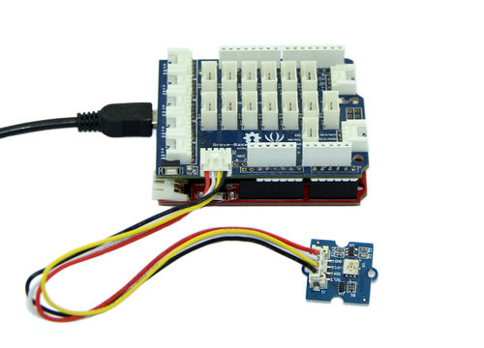
2. Download the library file:Barometer_Sensor Library;Unzip it into the libraries file of Arduino IDE by the path: ..\arduino-1.0.1\libraries.
3. Create a new Arduino sketch and paste the codes below to it or open the code directly by the path:File -> Example ->Barometer_Sensor->Barometer_Sensor.
/* Barometer demo V1.0
* Based largely on code by Jim Lindblom
* Get pressure, altitude, and temperature from the BMP085.
* Serial.print it out at 9600 baud to serial monitor.
*
* By:http://www.seeedstudio.com
*/
#include "Barometer.h"
#include <Wire.h>
float temperature;
float pressure;
float atm;
float altitude;
Barometer myBarometer;
void setup(){
Serial.begin(9600);
myBarometer.init();

}

void loop()
{
temperature = myBarometer.bmp085GetTemperature(myBarometer.bmp085ReadUT()); //Get the temperature, bmp085ReadUT MUST be called first
pressure = myBarometer.bmp085GetPressure(myBarometer.bmp085ReadUP());//Get the temperature
altitude = myBarometer.calcAltitude(pressure); //Uncompensated caculation - in Meters
atm = pressure / 101325;

Serial.print("Temperature: ");
Serial.print(temperature, 2); //display 2 decimal places
Serial.println("deg C");

Serial.print("Pressure: ");
Serial.print(pressure, 0); //whole number only.
Serial.println(" Pa");

Serial.print("Ralated Atmosphere: ");
Serial.println(atm, 4); //display 4 decimal places

Serial.print("Altitude: ");
Serial.print(altitude, 2); //display 2 decimal places
Serial.println(" m");

Serial.println();

delay(1000); //wait a second and get values again.
}
4. Open the serial monitor to receive the sensor's data including terperature, barometric pressure value, relative atmosphere pressure and altitude.
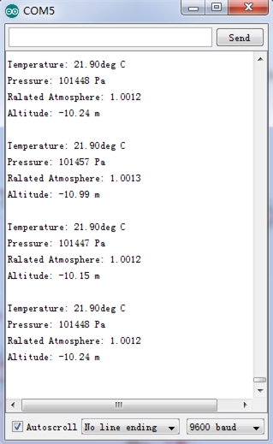
The following is a reference graph plotting out the relationship between altitude above sea level and barometric pressure.
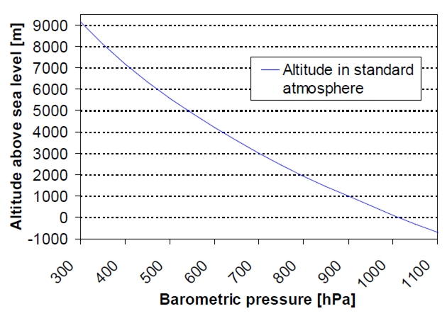
Resources
- Grove - Barometer Sensor Eagle File
- Barometer_Sensor Library
- Github repository for Barometer Sensor Library - new
- BST-BMP085-DS000-06

